ITP 120 Module 6
Laboratory
Chapters 9 and 10

In the Assignment tab of our Portal page download the file itp120mod6_1718.jar and itp120mod6deitel.jar. The second one has the examples from the textbook. The first one is the one we will be looking at in this module. There are a number of packages in this file. YOU WILL ONLY BE TURNING BACK IN A PACKAGE NAMED dwolffmod6 (except with your name) with the programs shown at the bottom of this document.

- Now we will look at a number of very important topic in Chapters 9 and 10 namely inheritance, polymorphism, final and abstract classes, and interfaces.
- Watch the PowerPoint movie for this module. Look at the textbooks examples. Study the examples in the version1 to version4 of the jar file that you brought into Eclipse and watch the associated movie. GREAT INFORMATION!! Study these hard.
- Version 1 – no connection between the classes.

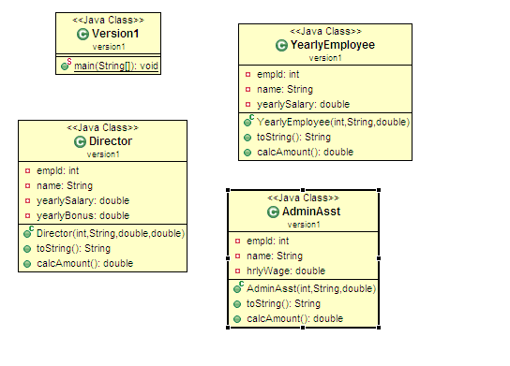
- Version 2 – inheritance but no abstract classes

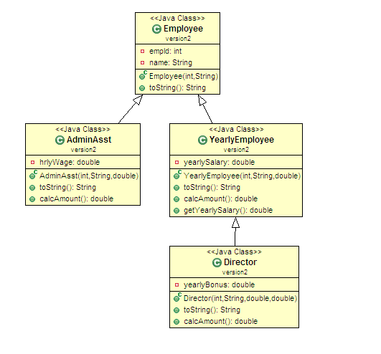

- Version 3 – has abstract class

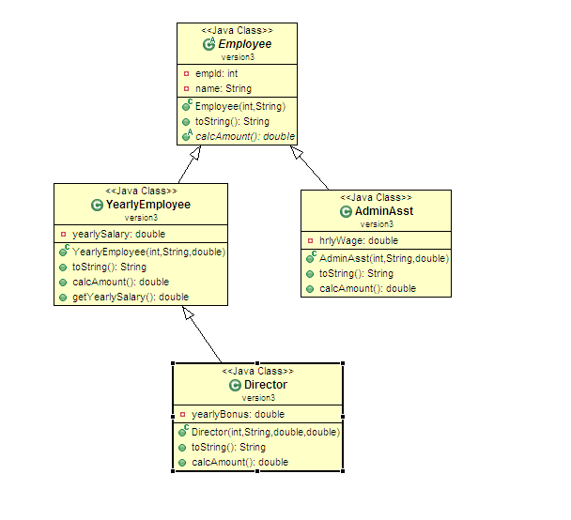

- Version 4 – interfaces, abstract classes

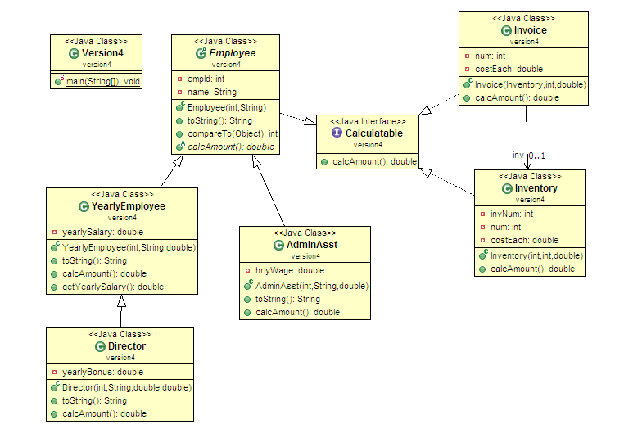
- Let’s look at another example together. Design a class named Person and its two subclasses named Student and Employee. Make Faculty and Staff subclasses of Employee. A person has a name, address, phone number, and employeeID. A Student has numHoursCompleted and major. The Student class has two subclasses, Undergrad and Graduate. Undergrads have a class status (freshman, sophomore, junior, or senior). A Graduate has a Faculty as an advisor and year (1 through 6). An employee has an office, salary, and dateHired. A faculty member has office hours and a rank. A staff member has a title.
- We will create these classes together. We need to consider which classes should be abstract. We need to override the toString method in each class to display the instance variables for the appropriate object type.
- Here is a UML diagram. Check out the code in the personpractice package in our jar file.

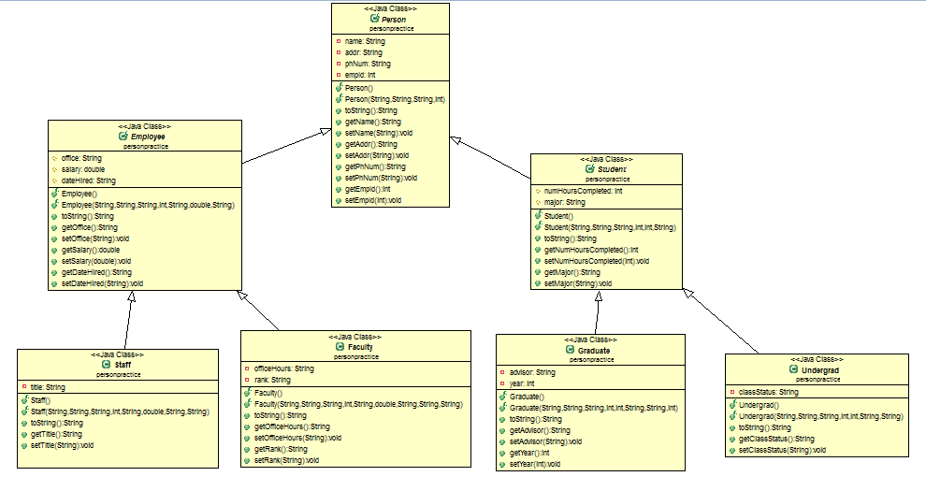

- For our lab, we will look at an example with the following classes and their relationships shown in the following UML diagram.
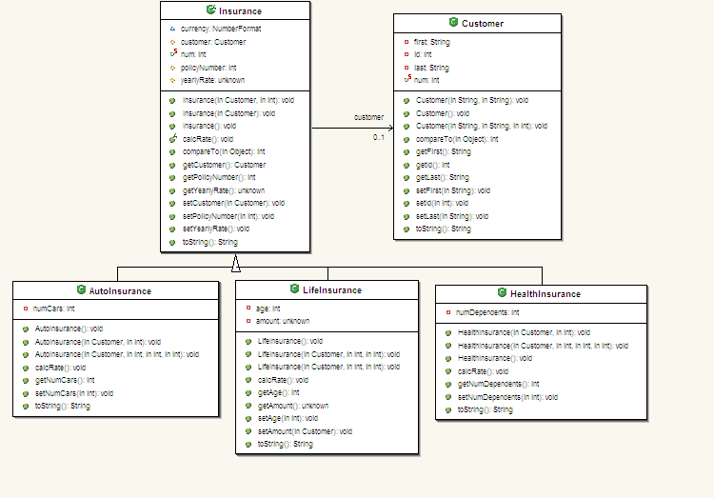

(These are cool diagrams, aren’t they? We will have a tool in Eclipse that will create these for us).
- I have put these files in the package named itp120mod6. Study the code carefully!
- Lots of things to learn here!! First we make Insurance an abstract class meaning that you can not make Insurance objects. We want only Auto, Health, or Life but no generic insurance policies. But move any fields or methods to here that are common for all three of these classes. To create the AutoInsurance (and likewise the others) use public class AutoInsurance extends Insurance. I have finished the AutoInsurance class.
- Note carefully how the code uses inheritance in the constructors and toString methods. Use the word super to refer to the class directly above in the hierarchy.
- TO DO: Finish the HealthInsurance and LifeInsurance classes.
- TO DO: Add a class called ArtInsurance that inherits from Insurance. Look at the other three classes as a pattern. ArtInsurance should have new fields of String description (describes the art work) and double value (the value of the art work that you are insuring). Make certain your toString method prints these out. You can use whatever calcRate() calculation that you like for ArtInsurance.
- TO DO: At this point, all of your red Xs should be gone! The program that runs is TrackInsurance. Open this up and add five instances of your ArtInsurance class at the noted location in the main method. Use whatever data you like.
- Now run TrackInsurance. The menu will show up! I have coded the methods for choice 2 (print all insurance information) and choice 7 (quit!). You now need to make all of the choices work correctly. To do this, we will need searches and sorts so let’s look at a similar example before you continue. I can not emphasize enough that in Java, we rarely write code from scratch, but beg, borrow, and steal it. However, you still need to understand it to be able to adapt it to your needs.
- Open up the package named search_sort. Here we have Customers that have Accounts. The program that runs is SearchNSortExample. It is not as sophisticated as ours - not having a menu to choose from. But the methods will be very similar to what we need!
- Study the code and comments to understand how the methods work. Note that when you want to search for a customer, we use a while loop and stop when we find the customer. When we search for a customer’s accounts, we use a for loop since we do not know how many accounts a customer might have so we need to look throughout the entire ArrayList.
- Look how easy it is to sort ArrayLists!!! The Collections class has a method named sort that looks like the following in the APIs (you might want to go and look at it!)

static | sort(List<T> list)  Sorts the specified list into ascending order, according to the natural ordering of its elements.
  <T extends Comparable<? super T>>
  void
- Note that the sort methods in the Collections class is a static method. That means that I can do Collections.sort() and do not have to create an instance of the Collections class to use this method (remember that we did that with the Math class in an early module). It takes a List for the argument and the ArrayList is a List. (How do I know that? The top of the API for the ArrayList says

java.util
Class ArrayList<E>
java.lang.Object
java.util.AbstractCollection<E>
java.util.AbstractList<E>
java.util.ArrayList<E>
All Implemented Interfaces:
Serializable, Cloneable, Iterable<E>, Collection<E>, List<E>, RandomAccess

- Note one of the interfaces is the List -- so far, so good! (You know all about interfaces from the quiz in this module). Back up a page for the API for the sort method. The <T> means that the parameter can be any “type” (which means class or interface). But note on the left that it says that “T extends Comparable” (another interface that we discussed in the quiz). So to be able to use a class or interface as the Type, it must implement the Comparable interface. You should understand all of this from the quiz! Note that, as we discussed in the quiz, the Account class has a header of
public class Account implements Comparable<Account>
and that the compareTo() method is defined for this class
- TO DO: Finish the compareTo() method in the Insurance class.
- TO DO: Finish the code for the methods in TrackInsurance so that all the menu items work.
- NOTE: You will be sorting both by policy number and customer number. The first you can do with the short cut above since the policy number is a field in the insurance objects. Sorting by customer number takes a little more work. Look at the SortALByHand.java example in the serach_sort package and borrow this (you need to learn how to do this very well to become a good Java programmer). It will only need to be slightly altered. You could use the Comparator interface (see example in the package named comparatorEx) but we will stick with sorting the second one by hand.
- Run the appropriate areas of code through the debugger (the sortCustNum() method is cool to watch) and understand the code!!!!
- Finish your Insurance project.
- We need to look at more material on interfaces. Watch the movie on interfaces at http://learn.vccs.edu/webapps/bb-collaborate-bb_bb60/guest.recording.launch.event?uid=bd4c32e0-0f68-4190-9408-c1defba23985 and look at the material below as you do so.

Interfaces in Java

- Read the article Interfaces.doc included in the assignment. Watch the movie under Module Specific Goodies on interfaces. Here is the UML diagram for that movie.
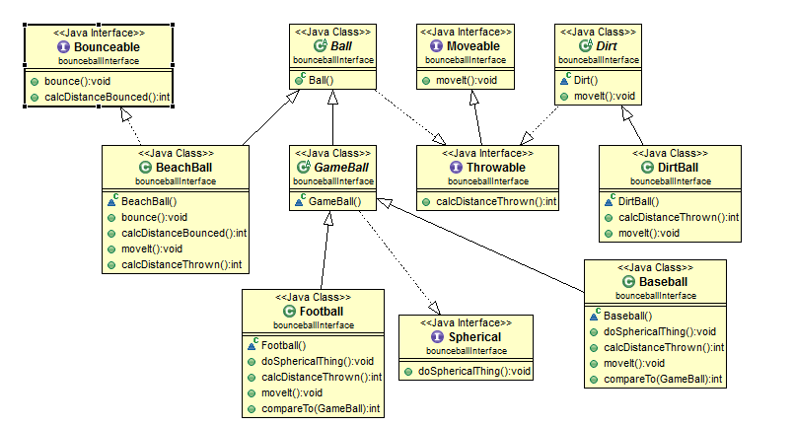

- To do: Look at the following UML diagram. Create a Java program that does not run named Robot. In the program, put the six types (“type” in Java is defined as classes plus interfaces) and write the appropriate methods (either abstract or stub – they do not need a body). Since the program is named Robot.java, only the Robot class (or interface – which ever you choose for it) can be public. The rest can use the default access modifier.
- NOTE: since all methods in interfaces MUST be abstract, UML diagrams usually do not show this. Make each type either a class or an interface according to the diagram. Make certain to “extend” and “implement” as the diagram has it drawn. You need to put the methods in the exact location where I have them in the UML diagram in all classes but RoboSapien and RoboRaptor. No extra ones are allowed, so, for instance, Robot is an abstract class (see the A on top of the C in the diagram) with no methods. Then add any methods needed in RoboSapien and RoboRaptor to make the red X go away. You do not need a main method anywhere or a driver program. The project is not meant to run. If you did want it to do so, you would add another class for the driver (but I am not asking you to do so).

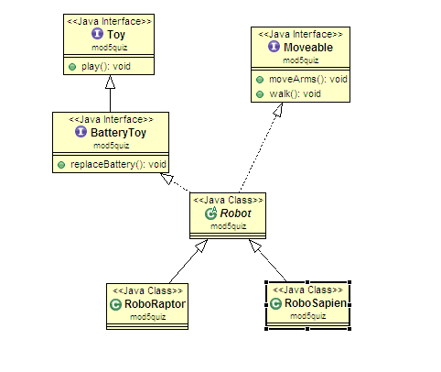

Make certain that you have completed the following:.
.
Step #14 above. Finish HealthInsurance and LifeInsurance
Step #15 above. Write a blueprint for ArtInsurance
Step #16 above. Add 5 ArtInsurance objects to the main program
Step #23 above. Write the compareTo() method for the Insurance class
Step #24 above. Get the rest of the menu items to work.
Step #30 above. Write a program named Robot that has the six types in the UML above

Your final package should have eight programs in it, the five types of Insurance, TrackInsurance, Customer, and Robot.

NOTE: before turning this in, check the top of each class for “stray imports”. Open up the + sign and see what imports are there. What happens is that if you copy code from one package to another, Eclipse assumes you are importing that class and writes an import statement for you. You do not get red Xs (since your project explorer has that package in it) so you may not notice it but I will get them since I do not have the same package structure as you.

NOTE: When printing from ArrayLists, it is often confusing which is the object and which is the ArrayList. If you have an ArrayList named cust of type Customer and you do

for (Customer cus : cust)
System.out.println(cust.toString());

OR

for (int i=0;i<cust,size();i++
System.out.println(cust.toString());

You will get the entire ArrayList printed out over and over (the number of times will equal the number of objects in the list) since cust is the name of the ArrayList – not the individual items. What you should do is”

for (Customer cus : cust)
System.out.println(cus.toString());

OR

for (int i=0;i<cust,size();i++
System.out.println(cust.get(i).toString());

And do specifically call the toString() methods even if that is the default if you leave it off.

